MENG 433 Casting and Welding
Fall 2002

Friction Stir Welding
Experiment 4

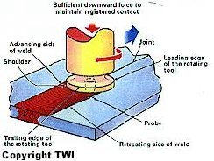

Fig. 1 Friction Stir Welding process¹

Friction Stir Welding (FSW) is a novel welding technique that was invented by The Welding Institute of the United Kingdom in 1991. This process was initially invented to join hard–to- weld metals and alloys, especially aluminum alloys. What is so unique about FSW is that it is a solid state welding process that does not require the melting of joined sections. Accordingly, FSW is capable of producing non-defective weldments provided that the welding parameters are satisfactory. In the current project, FSW was adapted to an automatic milling machine through the design of the welding tool and work holding device.

Joint Geometries
A friction stir weld (FSW) system for welding and weld repair can be used on the manufacturing floor, as well as in the laboratory environment. This FSW system can be used in a wide variety of welding and weld repair applications. It is capable of handling up to 6,000 pounds (26.7 KN) of axial load while operating within close tolerances. ²
The FSW process has been used for the manufacturing of butt welds, overlap welds, T-sections, fillet, and corner welds. For each of these joint geometries specific tool designs are required which are being further developed and optimized. The FSW process can also cope with circumferential, annular, non-linear, and three-dimensional
welds. Since gravity has no influence on the solid-phase welding process, it can be used in all positions such as, horizontal, vertical, overhead, and orbital.
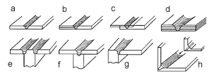

Fig. 2 Examples of FSW joint geometries ²

Advantages
FSW process has many advantages that result from the fact that the welding process occurs at the solid state. These advantages are³:
- Low distortion even in long welds
- Excellent mechanical properties as proven by fatigue, tensile and bend tests
- No fume
- No porosity
- No spatter
- Low shrinkage
- Can operate in all positions.
- Energy efficient
- Non-consumable tool
- One tool can typically be used for up to 1000m of weld length in 6000 series aluminum alloys
- No filler wire
- No gas shielding for welding aluminum
- No welder certification required
- Some tolerance to imperfect weld preparations - thin oxide layers can be accepted
- No grinding, brushing or pickling required in mass production¹³
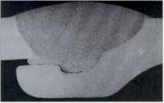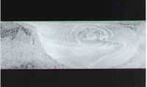
Traditional Weld FSW Weld

Fig. 3 Difference between traditional and friction stir welding ⁴

Limitations
- Welding speeds are moderately slower than those of some fusion welding processes (up to 750mm/min for welding 5mm thick 6000 series aluminum alloy on commercially available machines).
- Work pieces must be rigidly clamped.
- Backing bar required.
- Keyhole at the end of each weld.
Equipment

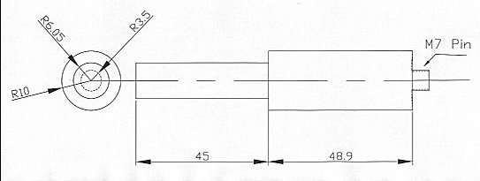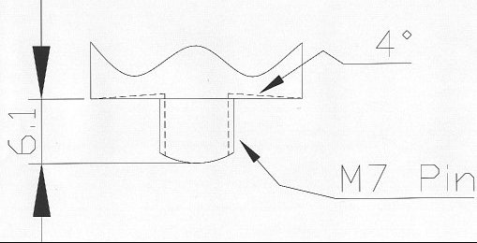

Fig. 4 FSW Tool Fig. 5 FSW Pin

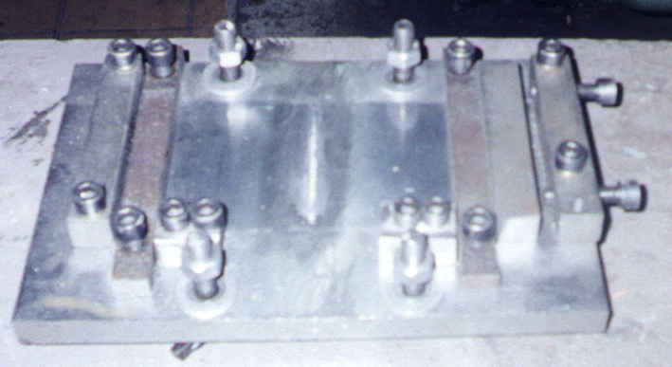

Fig. 6 the work-holding device
Process Sequence:
The FSW process is not an easy task to do. There are many steps and precautions that should be taken care of. If one of these steps or precautions is not well taken care of, a microstructural or mechanical property may be varied or one the process equipment will be damaged. Following are the sequence that took place with all the precautions:
- Mounting the work holding device on the milling machine table. The clamping plate should be strongly clamped to the table in order to withstand the forces exerted by the tool during the process. The clamping plate should be flat on the table by making sure the T bolts are fully screwed and that there are no objects under the plate. Otherwise, the tool may go deep or out of the work piece while passing between it. Before fully screwing the “T” bolts, the plate should be adjusted to make a 90° with the milling machine table; in other words, the plate should be parallel to the milling table.
- After making sure the clamping system is safely and accurately mounted on the worktable, the RPM and feed rate of the experiment should be well adjusted. Good care of the readings and the load handles should take place. Then after safely mounting the tool in the chuck of the machine, turn on the spindle to check that the tool is turning smoothly.
- Next, the work pieces should be grounded in welding zone with a grinding paper of grade 400 (for aluminum), to remove any stains, oil, and the Al₂O₃ layer that is formed on the top of the aluminum sheets. Then, mount the 2 work pieces on the clamp plate and make sure that they are strongly fixed. While fixing them from the side, do not screw the Alan key screws so tight so that the work pieces will not form an angle with the plate.
- Move the worktable towards the tool in order to center the tool so that it becomes just above the point of contact between the 2 work pieces joining line.
- Move the table in the upward direction and let the work pieces just touch the bottom of the shoulder. Check if there is enough clearance between the tool pin and the steel plate by inserting a small piece of paper between the pin and the steel plate, sometimes the sheet thickness may not be uniform and can cause problems, and see if the paper will pass between them or not. Make a mark on the lever arm that moves the table for that position to set the tool pin penetration through the work pieces.
- Wear goggles for eye safety.
- Bring down the worktable from the tool and turn on the spindle.
- Move the table back again towards the tool until the pin starts penetrating at the joint line. Then, move the table upward until the mark made on the arm is reached, at this stage, the shoulder is just in contact with the sheet surface. Then let the table move automatically according to the feed rate set in step 2.
- Keep away from the milling machine to avoid the possibility of a part of the scrap may hit you and for safety.
- Wait until the shoulder is just about to touch the edge of the work piece and move the table downward and turn off the feed rate and spindle.
- Unscrew all the Alan keys fixed to the clamping system and take off the welded work pieces.
- Wear gloves to avoid skin burns during removal of the FSW work piece. Take care it is very hot and may cause some burns.
- If there will be another welding process, wait a moment until the tool cools down. When the tool is cooled, clean it using a nut or the screwing die that screwed the pin and make sure to use the same screw size. Then clean the steel plate and repeat the steps again in order to perform the new welding.

References
1. http://www.twi.co.uk/j32k/unprotected/band_1/fswequip.html
2. http://www.fpe.co.uk/frictionstir2.htm
3. http://www.twi.co.uk/j32k/unprotected/band_1/fswjoint.html
4. http://www.twi.co.uk/j32k/unprotected/band_1/fswqual.html

